Ergonomics in Interior Design

Ergonomics is a fundamental principle in interior design that focuses on creating environments that support human comfort, efficiency, and well-being. Whether in homes, offices, or public spaces, an ergonomic design ensures that furniture, layout, and spatial arrangements align with the physical and psychological needs of the users. This article explores the concept of ergonomics, its importance in interior design, and practical applications across different spaces.

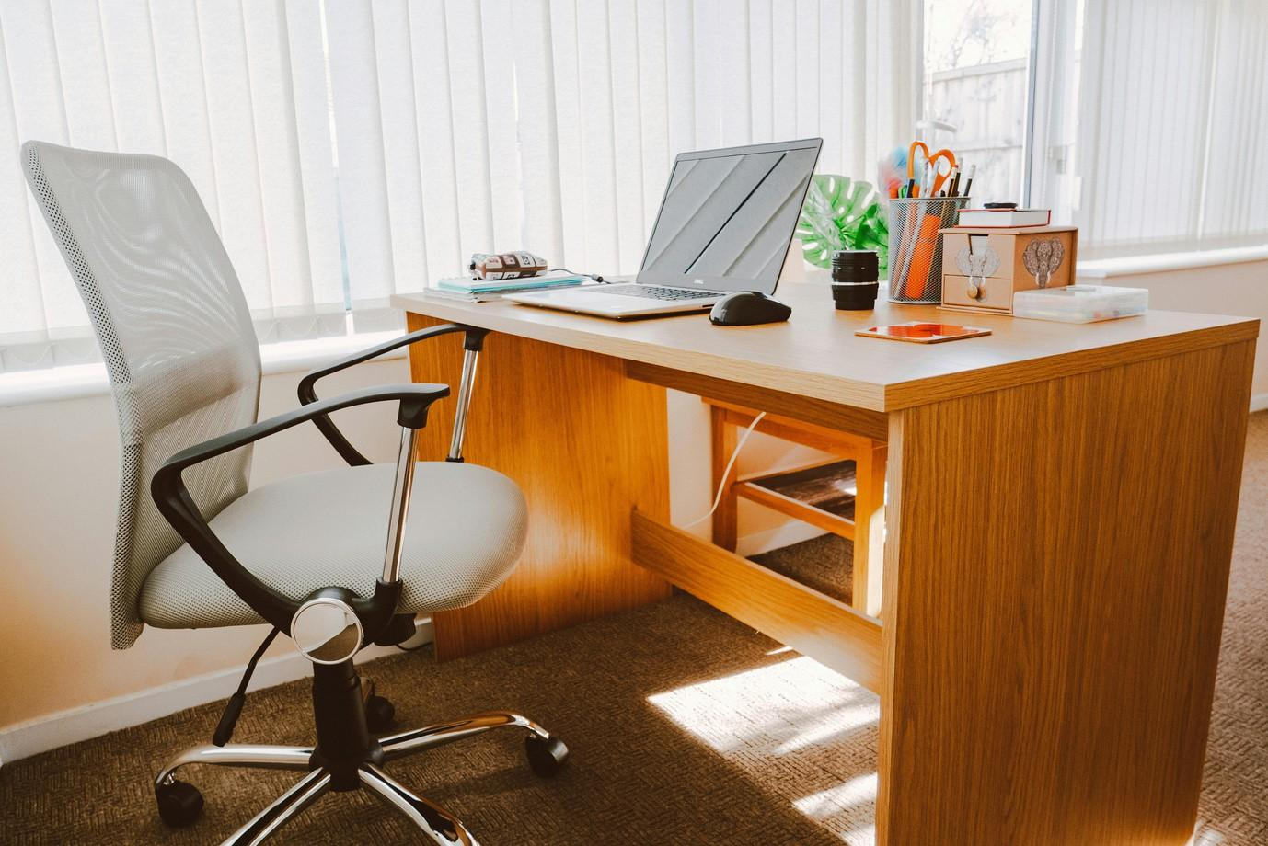

Fig 1. Pexels (nd) White Rolling Armchair Beside Table

# What is Ergonomics

Ergonomics, also known as human factors engineering, is the science of designing environments, tools, and systems that fit the capabilities and limitations of the human body. The term originates from the Greek words ergon (work) and nomos (law), meaning "the laws of work." In the context of interior design, ergonomics ensures that spaces are functional, comfortable, and safe for their occupants.

Key aspects of ergonomics include:

**Anthropometrics:** The study of human body measurements to determine optimal dimensions for furniture and spatial design.

**Biomechanics**: Understanding body movement and posture to minimise strain and discomfort.

**Cognitive Ergonomics:** Designing spaces that enhance mental well-being and reduce stress.

# The Importance of Ergonomics in Interior

Design

## Enhancing Comfort

One of the main goals of interior design is to create spaces where people feel at ease. Ergonomics plays a crucial role in achieving this by ensuring that furniture, room layouts, and materials are designed to provide maximum comfort.

Ergonomic design prioritises the comfort of users by ensuring that furniture and spatial arrangements promote proper posture and movement. Whether it's an office chair that supports the spine or a kitchen counter set at an appropriate height, comfort is a critical aspect of well- designed interiors.

## Improving Efficiency and Productivity

A well-designed space not only looks good but also supports the activities performed within it. Whether in a home office or a corporate workspace, ergonomic design helps individuals work more efficiently by reducing strain and enhancing movement.

Adjustable furniture, proper lighting, and well-thought-out layouts contribute to a workspace where people can focus and perform at their best without experiencing discomfort or fatigue.

## Promoting Health and Safety

Ergonomics is critical in preventing health issues related to poor posture, repetitive movements, and prolonged sitting or standing. Poorly designed spaces can lead to problems such as back pain, neck strain, and fatigue.

By integrating ergonomic principles, interior designers can reduce these risks, ensuring that spaces promote good posture, proper support, and safe movement. For example, ergonomic office chairs reduce back strain, while non-slip flooring prevents accidents in high-traffic areas.

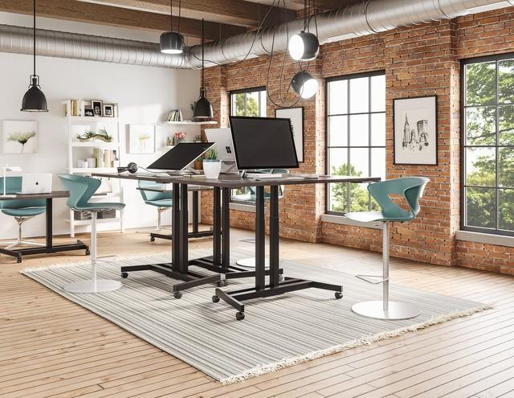

Fig 2. Pixabay (2024), Standing desk.

## Enhancing Aesthetics and Functionality

Ergonomics is not just about function—it also enhances aesthetics. Instead, it seamlessly blends functionality with design, creating visually appealing environments that serve their purpose effectively. A space that is both visually appealing and practical creates a sense of balance and harmony.

Thoughtful furniture placement, proper spacing, and user-friendly layouts contribute to a design that is not only beautiful, but also easy to navigate and use. Aesthetics and functionality should work together to create interiors that are both practical and inviting.

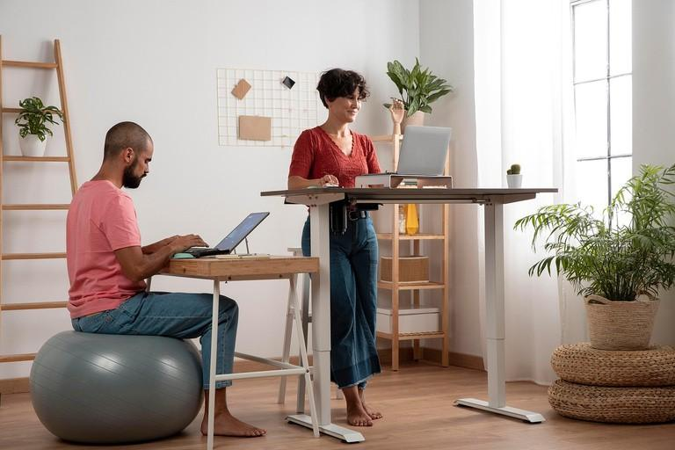

Fig 3. Pixabay (2024): Working, Coworkers, Office image

### Catering to Diverse Needs

Ergonomics considers the diverse needs of users, including children, elderly individuals, and people with disabilities. Every individual has unique physical and psychological needs, and a well- designed interior should accommodate everyone.

By incorporating universal design principles, spaces can be made accessible to all, ensuring inclusivity. Whether through adjustable furniture, barrier-free access, or adaptable layouts, ergonomic interior design ensures that spaces can be enjoyed by a wide range of users.

# Applications of Ergonomics in Interior Design

### Residential Spaces

Our homes are where we spend most of our time, and they should be designed to maximize comfort, safety, and convenience. Applying ergonomic principles in residential interiors ensures that spaces are easy to navigate and use. From the height of kitchen counters to the placement of furniture in a living room, every detail contributes to a comfortable and efficient home environment. By designing with the human body in mind, homeowners can enjoy spaces that promote relaxation and functionality. Here are some things to keep in mind:

**Living Rooms:** Furniture should be arranged to allow free movement and provide comfortable seating with adequate back support.

**Kitchens:** Countertop heights, storage placement, and appliance positioning should accommodate users' needs, minimising strain.

**Bedrooms:** Mattresses, bed heights, and lighting should support relaxation and proper sleep posture.

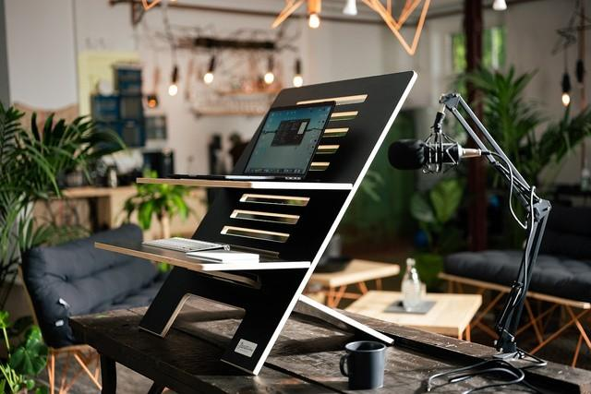

Fig 4. Pixabay (2024): Home Office.

### Workspaces and Offices

With the increasing demand for productivity and efficiency, ergonomic design has become essential in workspaces. Whether it’s a home office or a corporate setting, an ergonomically designed workspace helps reduce fatigue, improve concentration, and minimise health risks. Adjustable desks, chairs with lumbar support, and proper lighting contribute to a comfortable work environment that allows individuals to focus and work efficiently without experiencing discomfort or stress. What to consider:

**Desks and Chairs:** Adjustable chairs with lumbar support and desks at appropriate heights prevent posture-related health issues.

**Lighting:** Natural and artificial lighting should be balanced to reduce eye strain.

**Technology Placement:** Screens should be at eye level, and keyboards and mice should be positioned to avoid wrist strain.

## Commercial and Public Spaces

Public spaces such as retail stores, restaurants, and hotels need to be designed for comfort, accessibility, and usability. Ergonomic design ensures that customers and employees can move around easily, interact with their surroundings, and enjoy their experience. Well-placed furniture, properly sized checkout counters, and comfortable seating arrangements are all aspects of ergonomics that contribute to a positive experience in commercial and public spaces.

Considerations:

**Retail Stores/ SHops:** Aisle widths, counter heights, and checkout areas should be designed for ease of movement and accessibility.

**Restaurants:** Seating arrangements should be comfortable, and tables should be at an appropriate height for dining convenience.

**Hotels:** Guest rooms and lobbies should prioritise both aesthetics and comfort, ensuring ease of use for travellers.

## Healthcare and Educational Spaces

Healthcare and educational facilities require special attention to ergonomics to ensure comfort and safety for patients, students, and staff. In hospitals and clinics, ergonomic design helps reduce patient discomfort, improve mobility, and assist healthcare professionals in performing their tasks efficiently. In schools and universities, ergonomically designed furniture, proper lighting, and acoustic considerations help create a learning environment that supports focus, engagement, and physical well-being.

Hospitals and Clinics: Ergonomic hospital beds, accessible restrooms, and patient-friendly seating improve the healthcare experience.

Schools and Universities: Classroom furniture should support good posture for students and teachers, while lighting and acoustics should enhance concentration.

Ergonomics is a vital aspect of interior design that ensures spaces are comfortable, functional, and safe. By applying ergonomic principles, designers can create environments that enhance well-being, improve efficiency, and cater to diverse needs. Whether designing a home, office, commercial space, or healthcare facility, integrating ergonomics leads to better experiences for users. When aesthetics and functionality come together, interior spaces become truly livable and enjoyable.